Merton Youth Justice Service CAMHS Team
Dr Ali Shnyien, Clinical Psychologist and co-ordinator for Merton Youth Justice Service Child and Adolescent Mental Health Team describes how their integrated approach to service delivery is aligned with the THRIVE Framework for system change (Wolpert et al., 2019).

Background

Merton Child and Adolescent Mental Health Service (CAMHS) provides a service to young people age 12 to 18 years old and their families within the Youth Justice Service (YJS) across all sectors of care. The team currently consists of 1.0 WTE Clinical Psychologist team lead/co-ordinator and 2 roles which incorporate parts of the Liaison and Diversion Mental Health Assessment Service (0.5 WTE) and the Pupil Referral Unit Mental Health Team (0.5 WTE).

The service provides developmentally and trauma informed consultation, advice, training, and assessment alongside direct individual and/or family based interventions. Alongside the YJS, this service is provided into directly adjacent teams such as the Merton Contextual Safeguarding Team, Family Wellbeing Service and Children’s Social Care, supporting non-psychologist colleagues and carers when young persons are involved with the Youth Justice System.

In terms of direct work, the service holds two pathways for access for young people; the Liaison and Diversion pathway and Post-court pathway.

Liaison and Diversion Pathway

Those accessing the Liaison and Diversion pathway are primarily referred to the service by the police, having been arrested in the borough. All arrests for young people and stop and searches are sent to the Liaison and Diversion Network at the beginning of each week and the network includes representation from Merton YJS CAMHS, Speech and Language Therapy, an Education, Training and Employment Worker (ETE), the Police, Substance misuse services, Contextual Safeguarding Leads and managers from the Youth Justice Service (YJS).

In cases that are already open to the service, the Liaison and Diversion network offers the lead professional a consultation. Consultations can also be offered to schools and other educational establishments with aim to reduce the risk of exclusion. For cases not known to a lead professional, the YJS-CAMHS team can make an offer of assessment with a view to refer to adjacent services should a need be identified.

Another route to this pathway is through the South-West London Criminal Justice Liaison and Diversion Service. This team liaise directly with custody suites across the South-West London to discuss young people who are in distress in custody and require further input.

Post Court Pathway

The Post Court pathway is for young people who have received a conviction at court and receive a referral order, youth rehabilitation order, or a detention and training order. As a priority, the young person will be referred to YJS-CAMHS for a mental health screening assessment. As part of this pathway, requests may be made for specialist assessments.

The YJS-CAMHS team also lead on the formulation and intervention planning project within the Youth Justice Service. Creating case formulations allows the YJS and wider professional networks to generate hypothesises about how a young person’s story has impacted their pathway into the justice system and any adjacent problems the young person may be experiencing. It is a way of embedding a trauma-informed approach to think more contextually about young people and their family's experiences. This is a new approach being piloted within the YJS, which is hoped will become part of the assessment process. Multi agency formulations allow the YJS to share information, hypothesise, and jointly devise a storyline for this young person, this then allows the network to appropriately sequence interventions to meet the young person’s needs.

Sharing of information is often a barrier to integrated working, how do you manage this?

Being a member of NHS staff seconded into the Local Authority with access to NHS databases, CAMHS resources, and with direct links into CAMHS services across the borough& South-West London, Ali can bridge the communication gap through involvement in both teams. Ali can attend network meetings and share what is appropriate and relevant based on the referral of that young person, bearing in mind confidentiality and safeguarding. It also means that the team can make referrals directly within the meeting, such as for a CAMHS assessment, substance misuse work or family work.

In addition, network meetings build relationships among teams, promote meaningful conversations about a referral and make offering support a lot more integrated.

How has the service enabled a needs based approach to delivering care?

The service aims to engender a needs based approach through the screening process, allowing input from a multitude of professionals whilst giving multiple opportunities for a young person to identify their needs. It tries to understand the most important priority for the young person at that point in time and how the service and professional network can adapt to meet that need, bearing in mind other contextual factors.

Educational work can be done with a young person to support them to engage, or think about how they can organise themselves. If a young person wishes to engage in some emotional regulation work with a YJS Case Practitioner they have got an established relationship with, clinical oversight and supervision can be provided to the Case Practitioner to build their capacity to do this work. This AMBIT (Adaptive Mentalization Based Integrative Treatment) based approach is also offered to workers in adjacent teams such as the Merton Contextual Safeguarding Team.

The service aims to be consent-based from the start. From the initial screening appointment, it is made clear that the young person does not have to speak to a professional if they do not want to. This enables them to have some control over the situation, where they may feel they lack control or choice in many other instances.

What role does education, training and employment have with the service?

A dedicated Education, Training and Employment Worker supports young people to access education, training and employment. They can access the team or wider network for support. The YJS help education settings adapt to meet the needs of a young person, for example during exams, so that they are supported to perform and succeed. There is flexibility in the environment where the team can meet a young person, such as delivering sessions in schools. Consultation is offered to education settings, and training sessions delivered to schools and colleges as needed. Support can also be vocational and has included supporting young people to attend music studios and other creative and/or vocational activities to help best meet their needs holistically.

How does the service offer align with the THRIVE Framework needs based grouping?

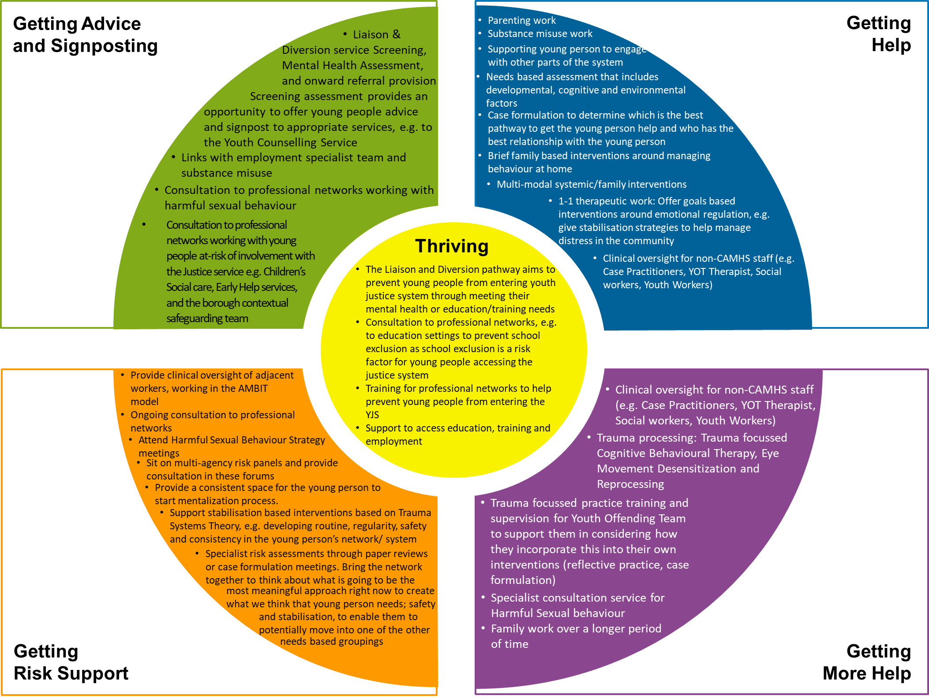

What feedback have you received about the service from service users and clinicians?

The main feedback from professionals has highlighted the integration of services across CAMHS and the local authority. Services are also perceived as being readily accessible. Being able to build meaningful relationships with workers enables an AMBIT informed ‘thinking together’ process that supports referrals without barriers. Professionals also value having clinical oversight and a freely available thinking space that doesn’t necessarily require scheduling a meeting or a referral.

Regular interpersonal feedback is gathered from young people in assessments and meetings about their experiences in the setting, including what has worked for them and what has not worked. Feedback is also obtained from Case Practitioner, as it can sometimes be difficult for a young person to share feedback directly. Being a consent-based service gives young people an option to choose whether they wish to continue with the intervention, which can further indicate their satisfaction with the service.

If you would like further information, please contact Ali Shnyien at Ali.Shnyien@swlstg.nhs.uk.

Edited by the National i-THRIVE Programme Team.

