i-THRIVE Toolkit: Fishbone Analysis
The purpose of the fishbone analysis, a type of root cause analysis, is to understand the cause of an identified ‘problem’ with the system you are trying to improve.

It is likely that although there may be many contributing factors to the maintenance of a problem, there will be one of two factors that are having the biggest effect.

The workshop below sets out what you need to do an interactive fishbone workshop with your team or stakeholders to explore the problem in depth, and in turn identify what the biggest contributing factor to the maintenance of it is.

Resources
- Post-its
- Pens
- Print outs of fishbone (or hand draw)

Workshop

To start:
- Begin by setting out what the problem is. Remember to use the data you have gathered and talk to the team about what the data is showing. The data may be quantitative or qualitative – but it is essential you have evidence that the problem is really a problem. If you haven’t done the data analysis stage then go back and gather your evidence before doing the fishbone workshop, or you may find you are trying to solve a problem that doesn’t really exist.
- Next, ask everyone to write down on Post-its what they think the contributing factors to the problem are. They should write one factor per Post-it and think of as many as they can.
- Next, ask the team to theme their Post-its as a group, either in small groups or as a whole – depending on how many attendees you have. To do this, they will need to discuss what they have written with each other. If more than one person has identified the same or similar contributing factors they can be grouped together as a theme.
- Once all the themes have been identified stick them onto the fishbone pictures – one theme per bone.
- You will begin to see which bone has the most Post-its connected to it. This shows you what the team feels the largest contributing factor to the problem is.

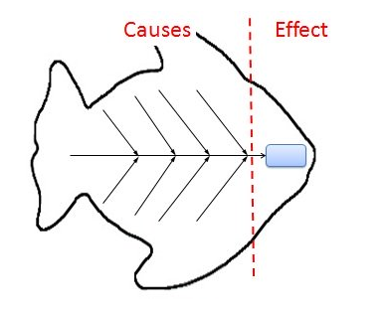

Image taken from: http://www.lindleysalliance.org/2018/09/04/fishbone-diagram-example-for-manufacturing-industry/fishbone-diagram-example-for-manufacturing-industry-fresh-fishbone-diagram-cause-and-effect-analysis-using-ishikawa-diagrams/

